1) Create a folder on Desktop or Any other place ex. users-api-server

2) Open Terminal and Go to the folder directory . ex. cd /Users/apple/Desktop/users-api-server

3) Init npm . " npm init -y "

4) Install JSON-SERVER. "npm i -g json-server"

5) Create "package.json" file into folder. ex users-api-server/package.json

{

"name": "users-api-server",

"version": "1.0.0",

"description": "",

"main": "index.js",

"scripts": {

"test": "echo \"Error: no test specified\" && exit 1"

“json:server”:”json-server — watch db.json”

},

"keywords": [],

"author": "",

"license": "ISC",

"dependencies": {

"json-server": "^0.16.3"

}

}

6) Create "users.json" file into flder. ex users-api-server/users.json

{

"users": [

{

"id": 1,

"first_name": "Robert",

"last_name": "Schwartz",

"email": "rob23@gmail.com"

},

{

"id": 2,

"first_name": "Lucy",

"last_name": "Ballmer",

"email": "lucyb56@gmail.com"

},

{

"id": 3,

"first_name": "Anna",

"last_name": "Smith",

"email": "annasmith23@gmail.com"

},

{

"id": 4,

"first_name": "Robert",

"last_name": "Brown",

"email": "bobbrown432@yahoo.com"

},

{

"id": 5,

"first_name": "Roger",

"last_name": "Bacon",

"email": "rogerbacon12@yahoo.com"

}

]

}

users-api-server folder should be look like following way

[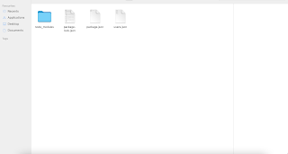](https://blogger.googleusercontent.com/img/b/R29vZ2xl/AVvXsEifUEWKIHw4fuYpE_Qy_p-GdrhnnllWPjORY_5GkshKwYLZZULXR44GxbYJHsyo5A9zMHdjVF4IhH2GVIB7ouL_ifymlc4DN8-58AAarM99hXhLo8V2-Qeha3bF31ukTUBPa5VQC3mmS0E/s2048/Screenshot+2021-08-09+at+4.37.56+PM.png)

7) Then start server. Go to the users-api-server folder on terminAL ex. cd /Users/apple/Desktop/users-api-server

The "json-server --watch users.json ". Then mock api server will start

output like below

[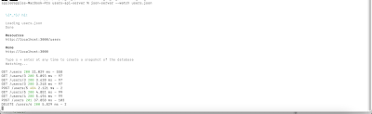](https://blogger.googleusercontent.com/img/b/R29vZ2xl/AVvXsEjI0yoOQsHriOV81h8g_wkC5jUxHtJHd_gH4lJsOt2PZX6vbG0qaNWvIkImnj0Cb0sqrtghDediCnNDsk5fmPPR2PnZZaQDM2_3dZiNpU0X6Zu1NnbncEyEo6KPp9D_vRrlrolqh3YMG1M/s2560/Screenshot+2021-08-09+at+4.28.55+PM.png)